

West Coast Collaborative
Specialist Mathematics Investigation 3
Integration By Parts & Numerical Integration
In Class Validation
Non-Calculator Section

No Calculators or notes allowed in the validation. Mobile phones must be switched off and in bags.

Name: _______________________________
Answer all questions in the spaces provided and provide full working to justify your answers.

Time allowed : 35 minutes Maximum marks = 32

Integration by Parts & Escalante’s Method

Using the method of Integration by Parts, determine the following indefinite integrals. Take care to simplify your answers as far as possible.

1. [ 4 marks ]

2. [ 4 marks ]

3. [ 5 marks ]

4. [ 6 marks ]

Now we have seen that integrals of the form , in which f(x) can be differentiated repeatedly to become zero and g(x) can be integrated repeatedly without difficulty, the Integration by parts formula can be used.
However, if many repetitions are required, the calculations can be cumbersome.
Jaime Escalante came up with a way to organise the calculations that saves a great deal of work. It is called Tabular Integration and it is illustrated in the examples below.

Example 1 Find

Let f(x) = x² and g(x) =
f(x) and its derivatives g(x) and its integrals

x² + cos x
2x - sin x
2 + -cos x
0 -sin x

Example 2: Find

Let f(x) = x³ and g(x) =

f(x) and its derivatives g(x) and its integrals

x³ + sin x
3x² - -cos x
6x + -sin x
6 - cos x
0 sin x

Part Two: Using the method of Tabular Integration or Escalante’s Method, find the following integrals:

5. [ 4 marks ]

6. [ 3 marks ]

7. [ 2 marks ]

8. [ 4 marks ]

END OF SECTION



West Coast Collaborative
Specialist Mathematics Investigation 3
Integration By Parts & Numerical Integration
In Class Validation
Calculator Assumed Section

No notes allowed in the validation. Mobile phones must be switched off and in bags.

Name: _______________________________
Answer all questions in the spaces provided and provide full working to justify your answers.

Time allowed : 25 minutes Maximum marks = 23

9. Approximate the area ,

a) using the Trapezoidal Rule with 6 strips [ 6 marks ]

b) using Simpson’s Rule with 6 strips [ 5 marks ]

ANOTHER NUMERICAL INTEGRATION TECHNIQUE - THE MID-POINT RULE
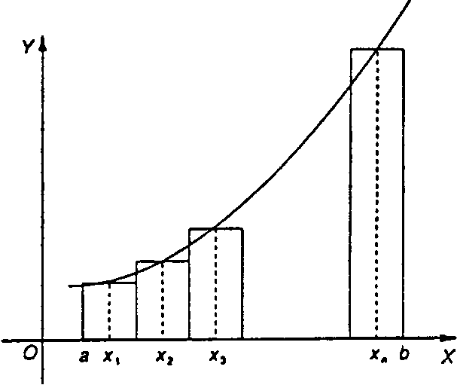
Let f be a continuous function in the interval [a; b]. Divide this interval into n subdivisions, each of width
Using these subdivisions as bases, n rectangles are drawn of width w and height f(x₁), f(x₂), f(x₃) where x₁,x₂, x₃are the x-coordinates of the mid-point of the subdivision, as illustrated in the figure below.

A numerical method of approximating the area of the region bounded by the curve the x-axis and the ordinatesx=a andx= b is to calculate the sum of the areas of these rectangles:

Example
Use the mid-point rule to find, approximately, the area bounded by the parabola defined by , the x-axis and the lines x = 1 and x = 3, using four intervals.

The x-coordinates of the mid-points of each of the four intervals are x = 1.25, 1.75, 2.25 and 2.75 and .

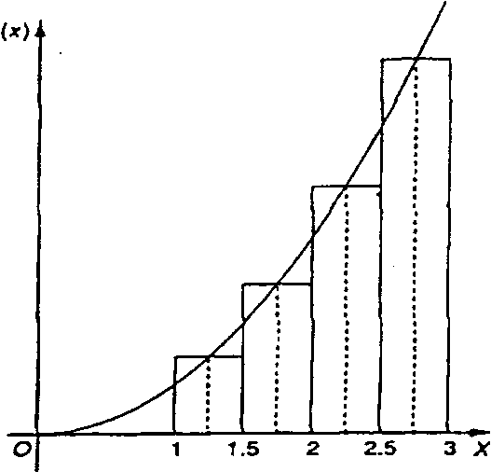

=
[f(l.25) + f (1.75) + f (2.25) + f (2.75)]

= 0.5[l.5625 + 3.0625 +5.0625 + 7.5625]

= 8.625

9 c) Use the mid-point rule to approximate the area [ 5 marks ]
d) Why is the “area” negative ? [ 1 marks ]

e) Which approximation is closest to reality? Justify your answer. [ 2 marks ]

f) Discuss why this is the case. [ 4 marks ]

END OF PAPER

